 | SEMINAR REPORT | 
A seminar Report on
AI Privacy Gateway

Submitted in partial fulfilment for the award of
THIRD YEAR DIPLOMA IN
COMPUTER ENGINEERING
By
Sr.  No | Enrolment  Number | Name of student
1 | 24610960174
2 | 24610960176 | Bagul Aditya Yuvraj
3 | 24610960178 | Bhadane Madhuri Ajay
4 | 24610960228 | Palve Pavitra Kiran
FOR THE ACADEMIC YEAR : 2026 – 2027

DEPARTMENT OF COMPUTER ENGINEERING
S.S.V.P.S's Bapusaheb Shivajirao Deore Polytechnic, Dhule
(Institute Code : 0059)

S.S.V.P.S's Bapusaheb Shivajirao Deore Polytechnic, Dhule
(An Affiliated Institute of Maharashtra State Board of Technical Education)
DEPARTMET OF COMPUTER ENGINEERING
CERTIFICATE
Sr.  No | Enrollment  Number | Name of student
1 | 24610960174 | Ansari Mohammad Sami Zahid Husain
2 | 24610960176 | Bagul Aditya Yuvraj
3 | 24610960178 | Bhadane Madhuri Ajay
4 | 24610960228 | Palve Pavitra Kiran

of CO5K Semester of Diploma in Computer Engineering of S.S.V.P.S’s B. S. Deore Polytechnic, Dhule (Inst.Code: 059) has completed the term work satisfactorily in Course Seminar Presentation and Project Initiation (Course Code: 315003) for the academic year 2026 to 2027 as prescribed in the curriculum.

Place : Dhule
Date : .....................

Signature: Signature:
Name : Name :

Subject Teacher Head of the Department

TABLE OF CONTENT
Sr. No. | Chapter | Page No.
 | Abstract | i
 | List of Figures | ii
 | List of Tables | iii
1 | Introduction | 1
2 | Literature Review | 2
3 | Information/Chapters | 3
4 | Advantages and Disadvantages | 8
5 | Conclusion | 9
6 | Project Initiation : | 10
6 | 6.1) Description of problem statement. | 10
6 | 6.2) Scope and objectives. | 10
6 | 6.3) Stake holder | 11
6 | 6.4) Platform/ Equipment/ Resources identification. | 12
7 | Seminar Presentation
 | Bibliography
 | References

ABSTRACT
A Brain Computer Interface (BCI) is an advanced technology that establishes direct communication between the human brain and external devices such as computers, robotic arms, wheelchairs, and prosthetic systems. It enables individuals to control devices using brain signals without requiring physical movement or conventional input methods. BCI systems acquire neural signals from the brain, process and analyze these signals, and translate them into commands that can operate various electronic and mechanical devices. The technology combines principles from neuroscience, biomedical engineering, artificial intelligence, and signal processing to create effective communication pathways between humans and machines.
The working process of a BCI involves signal acquisition, preprocessing, feature extraction, classification, and device control. Depending on the method of signal collection, BCIs can be classified as non-invasive, partially invasive, and invasive systems. Although challenges such as signal accuracy, high cost, and privacy concerns still exist, continuous advancements in machine learning, sensor technology, and neural engineering are rapidly improving the efficiency and reliability of BCI systems.
This seminar report presents the concepts, working principles, types, applications, advantages, disadvantages, challenges, and future scope of Brain Computer Interface technology. It highlights how BCIs are transforming human-computer interaction and contributing to the development of innovative solutions that bridge the gap between the human brain and intelligent machines.

LIST OF FIGURES

Fig. No. | Title | Page No.
1.1 | Working of AI Privacy Gateway | 4
1.2 | Architecture of AI Privacy Gateway | 6

LIST OF TABLES

Table No. | Title | Page No.
2.1 | Literature Review | 2
6.1 | Resources | 12

INTRODUCTION
A Brain Computer Interface (BCI) is an advanced technology that establishes direct communication between the human brain and external devices such as computers, robotic arms, wheelchairs, and prosthetic systems. It enables the transmission of information from the brain to a machine without relying on conventional pathways involving muscles and nerves. By interpreting brain activity and converting it into executable commands, BCI technology allows users to control devices using only their thoughts.
The human brain continuously generates electrical signals as neurons communicate with one another. Brain Computer Interfaces capture these signals using various techniques such as Electroencephalography (EEG), Electrocorticography (ECoG), and implanted microelectrodes. The collected signals are processed and analyzed using signal processing and machine learning algorithms to identify patterns associated with specific intentions or actions. These patterns are then translated into commands that can operate external devices.
BCI technology has gained significant attention in recent years because of its potential to assist individuals suffering from paralysis, stroke, spinal cord injuries, and other neurological disorders. It enables such individuals to communicate, control wheelchairs, operate prosthetic limbs, and interact with computers independently. In addition to healthcare applications, Brain Computer Interfaces are increasingly being explored in gaming, robotics, virtual reality, smart homes, military systems, and human-computer interaction research.
A typical BCI system consists of several stages, including signal acquisition, signal preprocessing, feature extraction, classification, and device control. Depending on how brain signals are collected, BCIs can be classified as non-invasive, partially invasive, and invasive systems. Non-invasive methods, particularly EEG-based systems, are widely used due to their safety and ease of implementation, while invasive approaches provide higher accuracy and reliability.

LITERATURE REVIEW
1. Brain-Computer Interface: Advancement and Challenges
This work presents a comprehensive review of Brain-Computer Interface (BCI) technology. It discusses signal acquisition techniques, signal processing methods, feature extraction approaches, and classification algorithms used in BCI applications. The study highlights major challenges such as signal noise, accuracy, reliability, and real-time implementation.
2. BrainGate: A Neural Interface System for Communication and Control
This work introduces BrainGate, a neural interface system designed to help individuals with severe paralysis communicate and control external devices. The system uses implanted microelectrode arrays to record brain activity and translate neural signals into commands for computers, robotic arms, and assistive technologies.
3. Neuralink: High-Bandwidth Brain-Machine Interfaces
This work presents Neuralink, an advanced implantable Brain-Computer Interface developed for direct communication between the human brain and computers. The technology utilizes flexible neural electrodes and advanced signal processing techniques to improve neural signal recording, interpretation, and device control.
4. EEG-Based Brain-Computer Interface Systems
This work focuses on Electroencephalography (EEG)-based Brain-Computer Interface systems. It explains how electrical brain signals collected from the scalp can be processed and converted into commands for controlling wheelchairs, prosthetic limbs, robotic devices, and communication systems.
5. Machine Learning Approaches for Brain-Computer Interfaces
This work investigates the application of machine learning algorithms in Brain-Computer Interface systems. The technology aims to improve brain signal classification accuracy, reduce processing errors, and enhance communication between the human brain and external devices.
6. Brain-Computer Interfaces for Neurorehabilitation
This work explores the use of Brain-Computer Interface technology in neurorehabilitation and recovery programs. The system assists stroke patients and individuals with motor disabilities by creating a direct communication pathway between the brain and rehabilitation devices, helping restore motor functions.

7. Deep Learning-Based Brain Signal Analysis
This work proposes the use of deep learning techniques for analyzing and decoding complex brain signals. The approach improves feature extraction and classification performance, resulting in more accurate interpretation of user intentions and efficient device control.
8. Brain-Controlled Robotic Systems
This work presents a framework for controlling robotic systems using brain signals. The system enables users to operate robotic arms, wheelchairs, and assistive devices directly through neural activity, improving independence and mobility for individuals with physical disabilities.
9. Assistive Communication Systems Using Brain-Computer Interfaces
This work introduces communication systems based on Brain-Computer Interface technology. These systems allow individuals with severe motor impairments and locked-in syndrome to communicate through thought-based commands without requiring physical movement.
10. Invasive and Non-Invasive Brain-Computer Interfaces
This work compares invasive and non-invasive Brain-Computer Interface technologies. The study evaluates their performance, signal quality, safety, accuracy, and suitability for various medical and research applications.
11. Brain-Computer Interfaces in Smart Healthcare
This work discusses the integration of Brain-Computer Interface technology in healthcare systems. The technology supports patient monitoring, neurological disorder management, rehabilitation, assistive communication, and remote healthcare applications.
12. Future Trends in Brain-Computer Interface Technology
This work reviews emerging developments in Brain-Computer Interface research, including artificial intelligence integration, wireless neural interfaces, advanced neuroprosthetics, and human-machine interaction systems. The study highlights the future potential of BCIs in healthcare, robotics, education, and smart environments.

Table No 2.1: Literature review:
Sr.  No. | Approach  Type | Technologies Used | Dataset | Key Objective | Limitations
1 | Brain-Computer  Interface:  Advancement and  Challenges | EEG, ECoG, neural sensors, signal processing, feature extraction and classification algorithms. | PII-Bench:  2,842  samples,  7 PII types  and 55  categories. | Evaluate whether  systems can  detect PII and  decide which  details are  relevant to a user  query and which  can be masked. | Models identify PII  more reliably than  they judge relevance.  Performance declines  on long prompts,  high-PII-density text  and multi-person  cases. More medical  and financial  examples are needed.
2 | Privacy-gateway  architecture with  anonymization/  substitution and  verifiable  processing. | Specific  programming  languages,  libraries or  models are not  specified in the  supplied notes.  Described  techniques:  sensitive-detail  anonymization/  substitution and  response  restoration. | Not publicly  specified in  the supplied  notes. | Place a secure  gateway between  users and a third-  party LLM,  anonymize  sensitive details  before  transmission, and  restore  appropriate  information in the  response. | The summarized  design applies  masking uniformly  rather than deciding  whether each PII item  is necessary for the  particular query.  Context-aware  relevance analysis remains an opportunity.
3 | Prompt  sanitization using  rule-based checks  and named-entity  recognition with  local processing. | Rule-based  checks; Named  Entity  Recognition  (NER); local  processing  components. A  specific NER  library/model is  not identified in  the supplied  notes. | Web-based  LLM  prompts; a  specific  named  benchmark  is not given  in the  supplied  notes. | Detect and  sanitize sensitive  information in  prompts before  they reach an  online AI service. | Sanitization may hide  details that are  necessary for the task  because the described  approach does not  explicitly assess the  relevance of each  detected detail. This  can reduce answer  quality.
4 | Browser-based,  risk-adaptive  prompt filtering  with user review  and policy-driven  actions. | TypeScript;  WebExtensions API; ONNX Runtime Web; regular expressions; lightweight token-classification model; browser storage. | Proposed  evaluation  metrics: precision, recall, F1-score, privacy-leakage rate, task utility | Detect sensitive  information locally, assign a heuristic risk score, and allow, warn, redact or replace content before it reaches an external AI service. | Effectiveness depends  on detection quality and policy calibration. Coverage is limited to supported browser interfaces, and it does not address all inference attacks or compromised devices.
5 | Client-side  representation transformation and perturbation before remote inference. | Python;  transformer tokenizer/  encoder; PyTorch; custom inference server; embedding perturbation. Differential privacy requires a separately specified and verified mechanism. | Proposed  evaluation metrics: reconstruction/attribute-inference attacks, task quality, bandwidth and latency. No fixed dataset is specified. | Transform a  prompt into a local representation and perturb it before sending it to a compatible cloud inference endpoint, reducing exposure of readable prompt text. | Embeddings may still  leak information, while stronger perturbation may harm semantic quality. The approach requires server-side adaptation and may not work with commercial chat APIs.
6 | Gateway-based  prompt-threat detection with minimal audit logging and fingerprint-based incident matching. | Python; FastAPI;  lightweight text classifier; cryptographic hashes; vector representations for similarity analysis. | Proposed  evaluation  metrics:  precision,  recall, F1-  score, attack  recall, false-  positive rate,  latency, log  size and  audit  usefulness.  No fixed  dataset is  specified. | Detect prompt-  injection attempts and sensitive-data exposure while avoiding a centralized archive of readable prompts; retain minimal event metadata. | Prompt injection is  context-dependent. Fingerprints can leak information or generate false matches, and detection does not replace tool authorization or output validation.
7 | Enterprise API  gateway security with authentication, authorization and machine-learning anomaly detection. | OAuth 2.0;  JSON Web Tokens (JWT); machine-learning-based anomaly detection. | Practical  enterprise contexts are described (banking, healthcare and IoT APIs); a specific benchmark dataset is not identified in the supplied notes. | Provide a secure  and scalable gateway for microservices, using authentication, authorization and anomaly detection to identify unauthorized access and DDoS activity. | Security checks add  latency; the ML component needs suitable training data and may produce false positives/negatives. The gateway can become a single point of failure and does not inspect PII content in requests.
8 | Federated-learning  framework combined with a secure API gateway and differential privacy. | Kong Gateway;  OAuth 2.0; JWT; TLS; differential privacy; proposed S-FLCF five-layer model; zero-trust security concepts. | CIFAR-10  and MIMIC-III; 100 simulated edge nodes, according to the supplied notes. | Study how secure  gateways can strengthen privacy in federated learning while raw data remains on local devices and model updates pass through a protected architecture. | The notes report  accuracy and communication overhead trade-offs and extra latency. They also flag the need for standard benchmarks and more scalability testing; some attack figures are described as illustrative.
9 | Replacement  Encoding (RE) for reversible data transformation, combined with IoT intrusion detection. | Replacement  Encoding; Random Forest; Deep Neural Network (DNN); Genetic Algorithm; secret-key-based reversible encoding. | CICIoT2023  The supplied table reports 94.81% Random Forest accuracy and 90.16% DNN accuracy with feature selection. | Camouflage  sensitive IoT data while preserving its usefulness for model training and supporting intrusion detection and preprocessing of mixed categorical data. | Encoding may be  vulnerable to AI-based cryptanalysis, collisions can occur under some encoding settings, and key management is important. The reported tests focus on IoT traffic rather than text prompts.
10 | Freeze-Then-  Search optimization of prompt variants using RETAIN, ABSTRACT and REDACT actions. | Fine-tuned  Qwen2.5-7B privacy comparator; GPT-5 and other LLMs for utility checks; priority-queue search; RETAIN / ABSTRACT / REDACT operations. | ShareGPT;  WildChat; CaseHOLD; MedQA. The supplied notes report evaluation across nine LLMs. | Find a minimally  revealing version of a prompt that still produces a useful answer, comparing privacy protection with task utility. | The search may  require many LLM utility checks per prompt. Results depend on the response model, utility is judged by an LLM, and models may overuse abstraction and reveal more than necessary.
11 | Mask-and-unmask  pipeline using entity detection, consistent placeholders and a local mapping dictionary. | GLiNER NER  model; Qwen2.5-14B with one-shot prompting; placeholder dictionary; local LLM processing. | 50 synthetic  immigration-law prompts containing about 460 entities, according to the supplied notes. | Allow legal users  to use external LLMs without exposing client PII by replacing detected information with placeholders and restoring values in the response when needed. | Evaluation uses  synthetic data from one legal domain. All detected PII is masked without checking whether it is relevant to the task; a proposed hybrid detector is not yet implemented in the supplied notes.
12 | Fine-tuning small  language models to detect PII spans, classify entity types and label query relevance. | Llama-3.1-8B  with LoRA; Llama-3.2-3B with LoRA; GPT-4.1-mini; synthetic-data generation and relevance labeling. | 2,307  synthetic QA samples covering 15 PII types, plus 150 real Reddit excerpts, according to the supplied notes. | Detect PII,  identify its type and decide whether it is relevant to the question (keep or mask), using a local model to limit disclosure to untrusted services. | Performance weakens  on long inputs and questions with few contextual hints. Relevance labels are binary, domain-specific rules are not modeled, and synthetic training data may not generalize to all prompt styles.

INFORMATION/CHAPTERS
1. Overview of AI Privacy Gateway:
An AI Privacy Gateway is a piece of software placed between the users and the external AI systems. It detects personal information in users’ prompts and obscures non-essential details, ensuring the privacy of personal data and helping to maintain the quality of responses provided by the AI service.
2. Personally Identifiable Information:
Overall, personally identifiable information (PII) encompasses any information that can pertain to a particular person. For instance, PII includes email addresses, phone numbers, physical addresses, financial data, and sensitive medical records. An AI Privacy Gateway scans through the provided text for any PII data and determines what information should be removed or replaced in order to prevent the disclosure of personal details.
3. Need for Context-Aware Privacy Protection:
While scanning through the text for PII data, an AI Privacy Gateway can eliminate some details that may be useful for generating a high-quality response. That is why there is a need for context-aware privacy protection that would identify relevant information and leave it intact while masking the PII data, thus, reducing the amount of personal data that would be processed by an AI system.

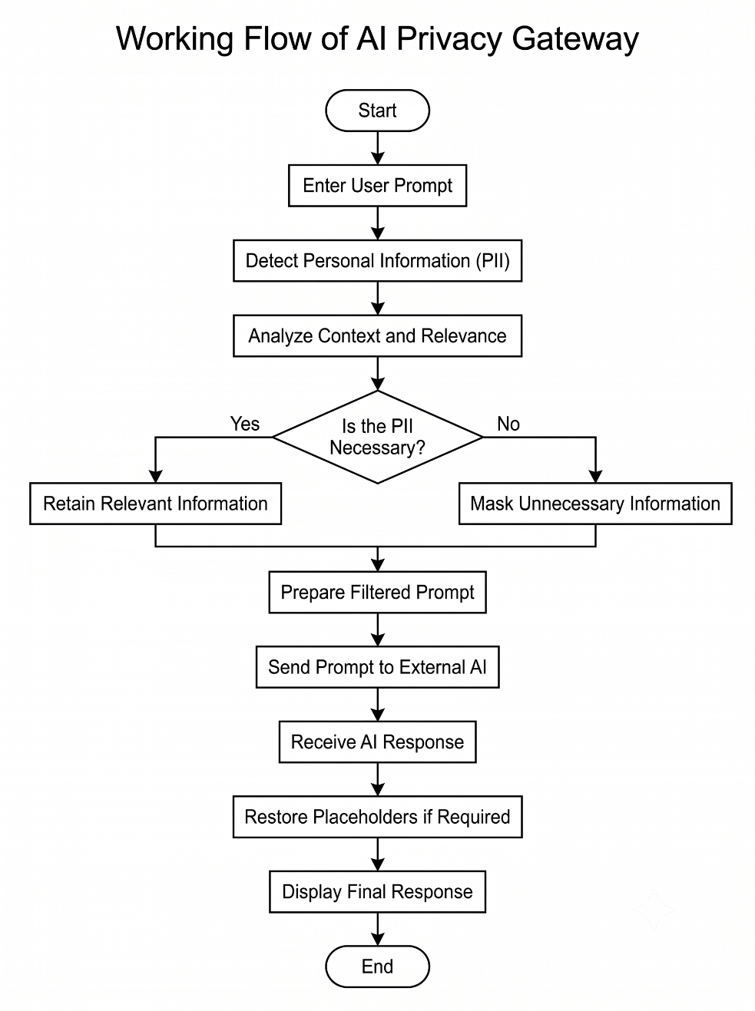
- Working Principle:
Fig 3.1: Working of AI Privacy Gateway
The working of the AI Privacy Gateway consists of the following steps:
1. Start: In the starting, the process of protecting user data is initiated when the user wants to interact with an external AI system.
2. Enter User Prompt: At this step, the user enters a question or a prompt, containing the information which an AI system needs to generate a response.
3. Detect Personal Information (PII): At this step, the gateway scans the prompt to identify the personal information like name, phone number, email address, and location.
4. Analyse Context and Relevance: Finally, the gateway analyses the detected information to determine if any information needs to be redacted or not.
5. Decide whether PII is necessary: If the information is relevant it is retained, if it is irrelevant it is masked to protect the users privacy.
6. Retain or Mask Information: Relevant information is retained and unnecessary information is masked.
7. Prepare filtered Prompt: The gateway uses the relevant information and masked information to prepare a privacy protected prompt.
8. Send Prompt to External AI: The prompt is sent to the external AI for processing.
9. Receive AI Response: The external AI processes the prompt and returns an AI response to the gateway.
10. Restore Placeholders if required: If required the gateway restores the placeholders using a protected mapping.
11. Display Final Response: The final response is displayed to the user with reduced exposure of personal information.
12. End: End of process after the final response is delivered to the user.

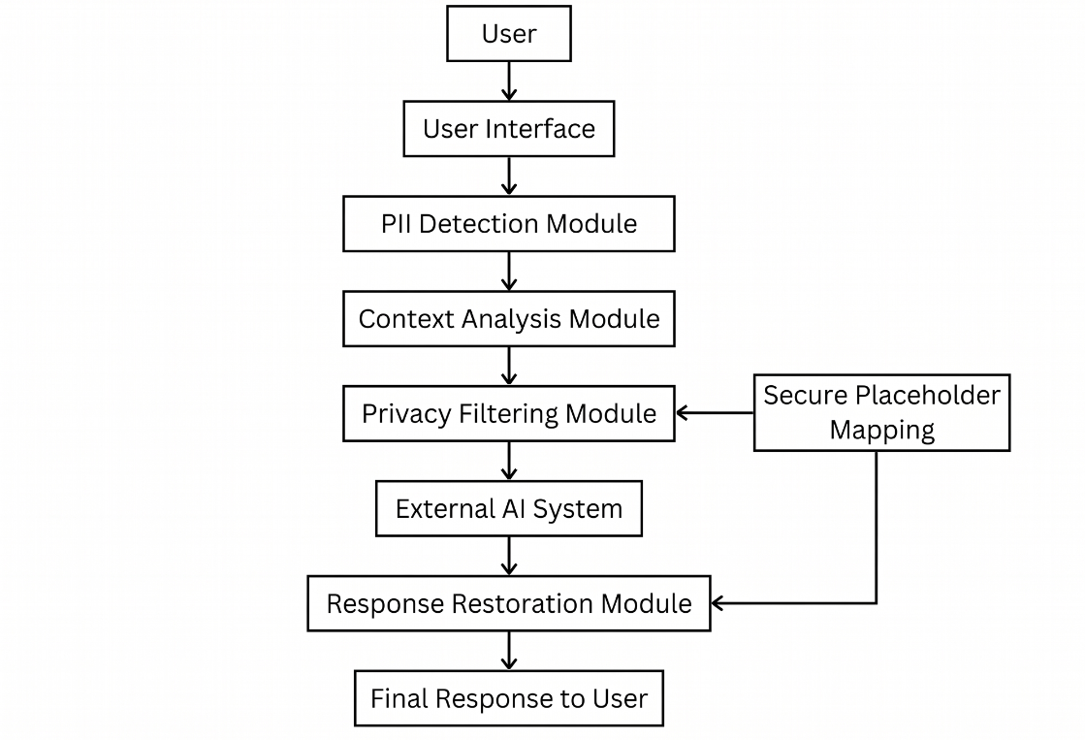
- System Architecture and Main Components:

Fig 3.2: Architecture of AI Privacy Gateway
- The components are: User Interface, PII Detection Module, Context Analysis Module, Privacy Filtering Module, External AI Interface, and Response Restoration Module. All of them perform their function to detect any PII, determine what data to hide and how, communicate with the outside, and present the final response to the user.
8. Technologies and Techniques Used:
Python can be used to build the gateway. Regular expressions will detect phone numbers and email addresses, while Named Entity Recognition will identify the names and places. Language models can be utilized to perform context analysis, and placeholder mapping may replace the sensitive details with labels like [PERSON_1] for the final technology selection based on the project implementation and existing resources.

8. Example of the PII Filtering:
“ My name is Rahul. I am a warehouse supervisor with a back pain. I live in Pune. How can I reduce fatigue at work?”
In this example, the gateway can remove the name and the place of residence as they are not relevant to the question. The result will be the following: “I am a warehouse supervisor with a back pain. How can I reduce fatigue at work?” Thus, the prompt will still contain the necessary personal identifiers to get an adequate response.
9. Privacy – Preserving Processing of the Response:
After the external large language model processes the request, the gateway can replace any of the identifiers with the placeholders. When the response is sent back to the user, the placeholders should be replaced with the corresponding data, if there are any. It should be noted that the privacy-preserving processing of the request will only minimize the risks of personal data exposure; it will not eliminate them. Therefore, the responses containing the identifiers should be masked to prevent the unauthorized access to the personally identifiable information.

ADVANTAGES AND DISADVANTAGES
4.1 Advantages:
1. Enhanced privacy due to the masking of unnecessary information prior to the request being sent to an external AI system.
2. Context preservation through the filtering mechanism, while retaining the necessary information to the question.
3. Ensured the response quality is not impacted due to the relevance of the masked information provided to the AI application.
4. Reduced exposure of information to the external AI application.
5. The solution can be easily integrated into different AI applications that may use different privacy-preserving mechanisms and/or APIs.
4.2 Disadvantages:
1. The gateway may fail to identify some personal information.
2. The gateway may misidentify ordinary text as sensitive information.
3. Incorrect masking of important details might degrade the quality of the response provided by the AI assistant.
4. The process may take more time to analyze and mask PII data compared to systems without this feature.
5. In cases where the context is not understood correctly by the system, the filtered question or response provided by the AI system might not be relevant.
6. Proper measures should be employed to protect the mapping between the placeholder tags and the actual values to avoid exposing the original private information in case of any security breach.

CONCLUSION
The AI Privacy Gateway offers a solution to the privacy concerns associated with using external AI systems. This tool can identify personally identifiable information (PII), evaluate the pertinence of data to the request, and mask irrelevant information in the prompt to the third-party AI service.
The AI Privacy Gateway can be a great addition to any AI service. By addressing the issues of PII, context assessment, privacy masking, and response reinstallation, the tool can be utilized to ensure privacy without compromising on the content of the response. While the implementation of such a gateway poses several challenges, addressing these issues can lead to a privacy-centric experience with AI services, which would increase the adoption rate of these technologies. In summary, an AI Privacy Gateway can be a great addition to any AI service by offering an additional layer of protection and ensuring that the user’s data is handled responsibly.

PROJECT INITIATION
a) Description of Problem Statement:
The development of Artificial Intelligence (AI) applications presents new threats to the privacy of personal information. Users provide prompts to external AI services, which may contain PII such as their names, contact details, emails, location, and health information. At the same time, the use of AI services requires users to provide prompts containing personal information that may subsequently be exploited. Conventional data masking techniques may eliminate all private data from prompts, thus reducing the usefulness of AI results. Therefore, a privacy gateway is needed that can identify PII, determine which personal data to mask, and allow generating prompts that still yield valuable results. The AI Privacy Gateway would be placed in between the user and an external AI service, scanning input prompts for PII, analyzing the relevance of each identified item, and masking the information. The gateway would ensure that only the necessary data are passed to the AI and reconstruct the response by replacing any masked items in the response with the corresponding placeholders.
Contextual analysis can make the AI Privacy Gateway effective by recognizing irrelevant PII and ensuring that only the necessary data are masked. This way, the privacy gateway would balance the need for personal data protection and the need for users to receive valuable AI results. For instance, when a user asks for directions to a specific address, the AI Privacy Gateway would mask the address, name, and contact details of the user while leaving the request intact. In another scenario, the AI Privacy Gateway would recognize the user’s location data if they ask for local weather forecasts.
b) Scope of the Project:
The purpose of this project is to design an AI Privacy Gateway that will safeguard the personal information of a user interacting with external AI applications. The system will detect Personally Identifiable Information (PII) in a user’s prompts and analyze the relevance of every piece of information to a specific query. It will make sure to keep relevant information and remove or mask the other details before sending the prompts to an outside system. The AI gateway can also put back the values in a response if they are needed and appropriate. The project aims to ensure that the user’s data exposure is unnecessary while still getting the required answers from the external applications.
Objectives of the Project:
1. To find out all the personally identifiable information from the user prompt;
2. To examine the connection between the found data and the user’s problem;
3. To mask or delete all the unnecessary personal data from the prompt;
4. To keep the required PII to ensure the results’ quality and usefulness;
5. To create a reliable placeholder system that would allow restoring the necessary information when needed;
6. To minimize the risk of providing users with excessive data.
c) Stakeholders:
The stakeholders of this AI Privacy Gateway are those who will use the product, develop and maintain the product, or be affected by its development and use.
1. End Users: These are people who will use AI applications and seek to protect their private information when using AI.
2. Developers: This group includes people responsible for developing, implementing, and maintaining the Gateway.
3. AI Service Providers: This category includes organizations providing third-party AI models or APIs for processing filtered prompts.
4. System Administrators: These are individuals who manage the gateway, ensure security, and perform maintenance tasks.
5. Organizations: This category includes universities, companies, and organizations that use AI applications and need more privacy and security when storing data.
6. Project Guide and Evaluators: These are faculty members who guide the project and evaluate its performance.
d) Platform / Equipment / Resources:
1. Platform:
The AI privacy gateway can be built on Windows or Linux operating systems through a Python programming language. Any code editor can be applied for developing and testing the software, for example, Visual Studio Code. For practical implementation, the system can be connected to the external artificial intelligence via an API to execute filtered prompts.

2. Equipment:
- Computer or Laptop: For developing and running the application.
- Processor: A standard modern processor suitable for Python development.
- RAM: Minimum 8 GB recommended; additional memory may be required for running local language models.
- Internet Connection: Required for accessing external AI services and downloading libraries.
- Storage: Sufficient space for source code, required libraries, and model files, if used.

3. Resources:
Resources | Name | Purpose
Operating System | Windows 11 | Host and run development tools,  editors, and local testing environment.
Programming  Language | Python 3.11 | Primary language used to implement  application code, scripts, and tests.
Code Editor | Visual Studio Code | Code editing, debugging, and extension  support for development.
PII Detection Tool | Microsoft Presidio | Detect and classify personally  identifiable information in text.
Pattern Matching | Python re Module | Perform regular-expression based  pattern matching and extraction.
NLP Library | spaCy | Natural language processing tasks such  as tokenization, parsing, and entity  recognition.
Language Model | Qwen2.5-7B-Instruct | Instruction-following large language  model for generation or assistance tasks.
AI Service | OpenAI API | Access hosted models and APIs for  additional AI capabilities and  integrations.

BIBLIOGRAPHY
- Ponomarenko, M., Abedini, S., Shafieinejad, M., Emerson, D. B., Mohapatra, S., and He, X. (2026). “CAPID: Context-Aware PII Detection for Question-Answering Systems.” Proceedings of the 19th Conference of the European Chapter of the Association for Computational Linguistics (EACL), Student Research Workshop, pp. 320–331. Available at: https://aclanthology.org/2026.eacl-srw.23/
- Zhou, J., Mireshghallah, N., and Li, T. (2025). “Operationalizing Data Minimization for Privacy-Preserving LLM Prompting.” arXiv preprint arXiv:2510.03662. Available at: https://arxiv.org/abs/2510.03662
- Demir, M. M., Otal, H. T., and Canbaz, M. A. (2025). “LegalGuardian: A Privacy-Preserving Framework for Secure Integration of Large Language Models in Legal Practice.” arXiv preprint arXiv:2501.10915. Available at: https://arxiv.org/abs/2501.10915
- Microsoft. “Presidio: Text Anonymization Documentation.” Available at: https://microsoft.github.io/presidio/text_anonymization/
- Microsoft. “Presidio: Getting Started Documentation.” Available at: https://microsoft.github.io/presidio/getting_started/
- Python Software Foundation. “Python Documentation.” Available at: https://docs.python.org/3/
- Hugging Face. “Transformers Documentation.” Available at: https://huggingface.co/docs/transformers/
- Meta AI. “Llama: Large Language Models.” Available at: https://www.llama.com/
- Qwen Team. “Qwen: Large Language Models.” Available at: https://qwenlm.github.io/
- OpenAI. “API Documentation.” Available at: https://platform.openai.com/docs/

REFERENCES
- M. Ponomarenko, S. Abedini, M. Shafieinejad, D. B. Emerson, S. Mohapatra, and X. He, “CAPID: Context-Aware PII Detection for Question-Answering Systems,” Proceedings of the 19th Conference of the European Chapter of the Association for Computational Linguistics (EACL), Student Research Workshop, pp. 320–331, 2026. [Online]. Available: https://aclanthology.org/2026.eacl-srw.23/
- J. Zhou, N. Mireshghallah, and T. Li, “Operationalizing Data Minimization for Privacy-Preserving LLM Prompting,” arXiv preprint arXiv:2510.03662, 2025. [Online]. Available: https://arxiv.org/abs/2510.03662
- M. M. Demir, H. T. Otal, and M. A. Canbaz, “LegalGuardian: A Privacy-Preserving Framework for Secure Integration of Large Language Models in Legal Practice,” arXiv preprint arXiv:2501.10915, 2025. [Online]. Available: https://arxiv.org/abs/2501.10915
- Microsoft, “Text Anonymization — Presidio Documentation.” [Online]. Available: https://microsoft.github.io/presidio/text_anonymization/
- Microsoft, “Presidio Anonymizer Documentation.” [Online]. Available: https://microsoft.github.io/presidio/anonymizer/
- Hugging Face, “Transformers Documentation.” [Online]. Available: https://huggingface.co/docs/transformers/en/index

SEMINAR and PROJECT INITIATION Assessment / Evaluation
Sr.  No | Enrollment  Number | Name of student
1 | 24610960174 | Ansari Mohammad Sami Zahid Husain
2 | 24610960176 | Bagul Aditya Yuvraj
3 | 24610960178 | Bhadane Madhuri Ajay
4 | 24610960228 | Palve Pavitra Kiran
Formative Assessment
Sr. No. | Criteria | Weightage | Obtained
1 | Selection Topic / Theme of seminar | 5
2 | Literature review and data presentation | 5
3 | Quality of Preparation and innovativeness | 5
4 | Q-A handling | 5
5 | Time Management | 5
6 | Seminar Presentation report | 10
7 | Selection of Theme of Problem Statement and its innovativeness | 5
8 | Stages of development of Action plan | 5
9 | Prototyping | 5
 | Total | 50
 | Scaled to 25

Sign :
Name : ---------------------------------------(Course Expert/s)

